|  |
| --- |
| **St. Frances Cree Bilingual School**  **2141 McPherson Ave** [**gscs.ca**](http://www.scs.sk.ca/fra) **6 Bateman Crescent**  **306-659-7310 306-659-7940**  **Pre-K to Grade 5 Grades 6 to 9**  **Principal: Lori McAuley**  **Principal (Bateman): Lori McAuley**  **Vice Principal: Sara Miskolzie**  **Vice Principal: Barry Kimbley**  **Office Coordinator/Secretaries: Ms. Joan Marcotte, Mrs. Sherry McEachern, Mrs. Ngozi Nwokeji**  **School Board Trustees (Liaisons): B. Elliott December 6th, 2022** |

|  |
| --- |
| DATES TO REMEMBER:  December 1st Pipe Ceremony with Land Based Club leaders  December 2nd Liturgy at St. Francis Xavier Parish 9:00-10:30am  December 6th Choir performance TCU 12:20-12:40pm  December 8th Director Greg Chatlain Liturgy/Reception Holy Family Cathedral  Gym Blast at Bateman location  December 9th PLD Day - no school for students  December 14th Liturgy at St. Francis Xavier Parish 9:00-10:30am  December 16th Interns last day  December 22nd Last Day of School  December 23-January 8th Christmas break  January 9th School Resumes |
|  |

**Principal’s Message**

On behalf of all the staff, we continue to welcome all new and returning students and families to St. Frances for the 2022-23 school year! It has been a busy few months.

We have started up our Team Leagues. Our first gathering was on November 4th at the McPherson location. The students were excited with the leagues starting up again. Our House Teams are four teams, Earth, Wind, Fire, Water.

Even though things continue to be different this year with safe school plans. We are encouraging a less stringent approach to school based COVID-19 mitigation. We no longer require masks within the school setting. However, we do continue to communicate updates and any recommendations for masking when indoors during periods of high community transmissions. We are in support of any students and staff who choose to continue to mask. We do recommend that those who are sick to stay home and isolate until symptoms improve.

Thank you for your support! As parents and guardians, you are the primary caregivers of your children. We encourage communication and value the relationship we have with you so that we can work together to create a positive learning experience for your child. Don’t hesitate at any time to reach out to us for any reason.

As a school that celebrates both the Gospel Virtues of the Catholic Faith, as well as the Tipi teachings of the First Nations Community…we are celebrating the Virtue and Tipi Teaching of Mikiwahp Kiskinohamakewina ***Hope*** this month. We are having our second liturgy for week one of Advent on December 2nd and the 14th at the Church.

**Three Way Conferences**

**Term 1** 3-Way Conferences were held on Thursday, November 24th in the evening from 3:30-7:30pm and Friday, November 25th from 9:00am-1:00pm. We had a great turn out and a lot of phone interviews. Thank you, parents and caregivers, for taking an active role in your child’s education, it means a lot to your child.

**Spirit Week**.

The school will be having spirit week on December 12-16th, students will be encouraged to take part and win prizes for the week.

12th- Christmas hat and head wear

13th – Jersey Day, red and green day

14th- Wacky hair day

15th- Christmas Shirt/sweater day

16th- PJ’s and bring you stuffy day

**Santa’s Gift Shop Bateman location** (New and gently used)

Tuesday, December 13th-Wednesday, December 21st.

Prices will range from $0.50-$10.00, all proceeds will go to the Student Tribal Council and other school activities. Donations are accepted for new or gentle used items in good selling condition from toys, jewelry to household items. Gifts for the whole family!! Free gift wrapping available.

Please note, shopping is for students only.

**Santa’s Visit**

Pre-Kindergarten to grade 5 at the McPherson location

December 12th am, 13th all day, 15th all day.

Photo’s will be taken with Santa.

***Choir***

Noon Festival of Carols at TCU

GSCS Schools will be performing on the following dates:

Tuesday, December 6

Thursday, December 8

Monday, December 12

Wednesday, December 14

**St. Frances Choir performance TCU 12:20-12:40pm Dec 6**

**Using Edsby**

We are now using Edsby for submitting absences, booking three-way/SPT conferences and accessing your child’s progress report.

Parents/guardians can easily submit an absence for their child using their smartphone and the Edsby app.

If you did not receive your invitation to Edsby please call the school.

**NOON LUNCH**

Students have the privilege of eating lunch at school when it is not possible to go home. This year we will continue to eat in our classrooms. All lunchroom expectations continue, including remaining in their classrooms during the eating portion of the lunch time, clean up after themselves, and be respectful. Supervision will be provided during the noon lunch hour. If you are dropping off lunch for your child(ren) please check in at the main office first and Joan or Sherry will call your child(ren) down to pick it up, or you can drop it off at their classroom.

**STUDENT ALLERGIES**

Please remember that we strive to be a nut free school. We have many students with nut allergies and want to ensure they are in a safe environment at school.

**LEAVING THE SCHOOL GROUNDS AT LUNCH**

For safety reasons, all students who stay for lunch are to remain on school property during the entire lunch hour. Students are not permitted to leave to go to a friend’s house or to the store during this time unless a parent/caregiver picks up their child from school to take them there. Thank you for your support and understanding. Keeping our students safe is our number one priority!

**SCHOOL ZONES/PARKING**

Please be reminded of the reduced speed to 30km/h in school zones on weekdays from 7:00am to 7:00 pm. The few extra seconds can save a child from serious injury. **As well, please avoid parking in the school bus or special needs (handicapped) loading zones.** Vehicles in these zones will be ticketed. There are 20 busses dropping off and picking up students and arrive at the school at 8:35am and 3:00pm Monday-Friday. Thank you for your cooperation and understanding.

**PROFESSIONAL LEARNING DAYS**

Greater Saskatoon Catholic Schools use Professional Learning Days for elementary school staffs for staff meetings, planning and professional development. On these days there are no students at school. Our next Professional Learning Day is on December 9th.

**CATHOLIC SCHOOL COMMUNITY COUNCIL**

Our next meeting is on **January 30th,2023** We will be meeting in person at the McPherson location. This is a great opportunity to be involved in your child’s education, be involved in decision making at the school level and meet parents of other children from St. Frances. We meet once every 2 months for no more than an hour. All are welcome, even if you come for just some of the meetings. Please call the school if you want more information 306-659-7310.

**CELL PHONE USAGE**

Many students carry cell phones for safety reasons and to have communication with family while away from their care. It is school policy that all cell phones will be powered down during school hours so as not to distract from the learning atmosphere. Student will have the opportunity to use the classroom phone if needed and/or parents can leave messages for the student through the main office. If a student is not following policy, they will be asked to bring their phone to the office for the day and then pick it up before they go home. Please review this expectation with your child.

**TOYS AND PERSONAL ELECTRONIC DEVICES**

We encourage students to leave all toys and personal electronic devices at home. We want to create an environment free of distractions and we also know that when a child loses or belongings go missing, it creates unnecessary hardship for that child. The school does not replace items such as toys or electronic devices if they are lost or stolen. Please share this expectation with your child.

**NUTRITION POSITIVE SCHOOL/NUTRITION PROGRAM**

St. Frances prides itself in being a nutrition positive school. We provide breakfast, nutritious snacks, and offer a nutritional lunch to those students who need it (students are encouraged to bring a lunch, if possible, but lunch will always be available to those who need one). We are a pop and energy drink free school and discourage students from bringing any pop into the school. We appreciate your support in growing healthy children!

* Nutrition Programs: Students may not help prepare food.

**BUS/TRANSPORTATION**

First Student will continue to drive students to and from school and transfer grades 5 to 9 students to St. Frances Bateman. Students provided with transportation will be expected to cooperate in a respectful and safe manner to and from school. Please call the school if you have questions regarding rules and regulations. We would also like to thank parents and students for their patience as we have been trying to “fine tune” our new schedule and routes with all our new students and the split campus school. **If you are picking up your child after school and they normally take the bus home, please have a written note to give to the teacher**. If you have a concern with bussing, please feel free to contact First Student directly at (306)343-2125 or late bus inquiry at 343-3300.

**Student Expectations**

Our school expectation for all students and staff is Miyo-Pimohtewin, meaning “walking in a good way”.

***Definition of bullying***: A student is bullied when he or she is *repeatedly* exposed to negative actions on the part of one or more students causing emotional, psychological, and/or physical harm. These negative actions are intentional and hurtful. Bullying can be verbal, physical, electronic/on-line, relational, and reactive. Bullying involves an *imbalance of power, creates fear,* and *is not gender specific*. As a school, we work with parents/caregivers to ensure each reported incident of bullying is addressed with appropriate consequences and accompanying teaching strategies to support the instigators of bullying.

***Definition of conflict:*** Conflict is a disagreement or a difference of opinion or interests *between equals*. The people involved in a conflict may disagree vehemently and emotions may run high. When conflict is badly managed, it may result in aggression. In a conflict, *both parties have power* to influence the situation. That is their goal.

Please report any incidences of conflict or bullying to the school if your child reports any such incidences to you at home. It is not always seen by adults in the building, your help and cooperation are greatly appreciated to ensure the safety of all students.

**Information from SHA**

**When and where to seek care**

Feeling unwell? Not sure where to go/what to do for advice or care? Choose where to go/who you contact based on your symptoms.

COVID self-test kits are available for pick up across the province ([www.saskatchewan.ca/covid19](https://l.facebook.com/l.php?u=https%3A%2F%2Fwww.saskatchewan.ca%2Fcovid19%3Ffbclid%3DIwAR3_RVQmsqRstXi1eoJBp-y-2L_61hN7bF9-4kM0sN-jAY2I88cu5fbIhHs&h=AT3EfQSxCMpkevU5W8h2vxE-Wno95Aub0rqXnIXCgnTra0K9n14-vW1dBGs4ftJAeZtpxmvPD4x7CQICtFFuqNdLHbvp_IxXNTHmilVpEL6hbcwZHK7GDoQLLVrEC6e5yQ&__tn__=-UK-R&c%5b0%5d=AT0GSbX3rfSrUHw8GclPZmctqEBATy80CB6d8Ib4QfNE8gCF3DaN0MKGDt2JhAFQfE_vYkDgGSeWDr3249ay92JERrVMi3DIVepcaRq4R0c46lpJN2MTt7T9gqs60TAs6hq_vgwYrJOFjVrggtoBr0GwdY3VLokgzV-Gx-JC6JxTX0DG4Tv41-PbcFUukMC7gTzmYV17WazX)). Keep a testing kit available in your home in case of illness. Always wear a mask if you feel unwell and have to leave your home to seek medical care.

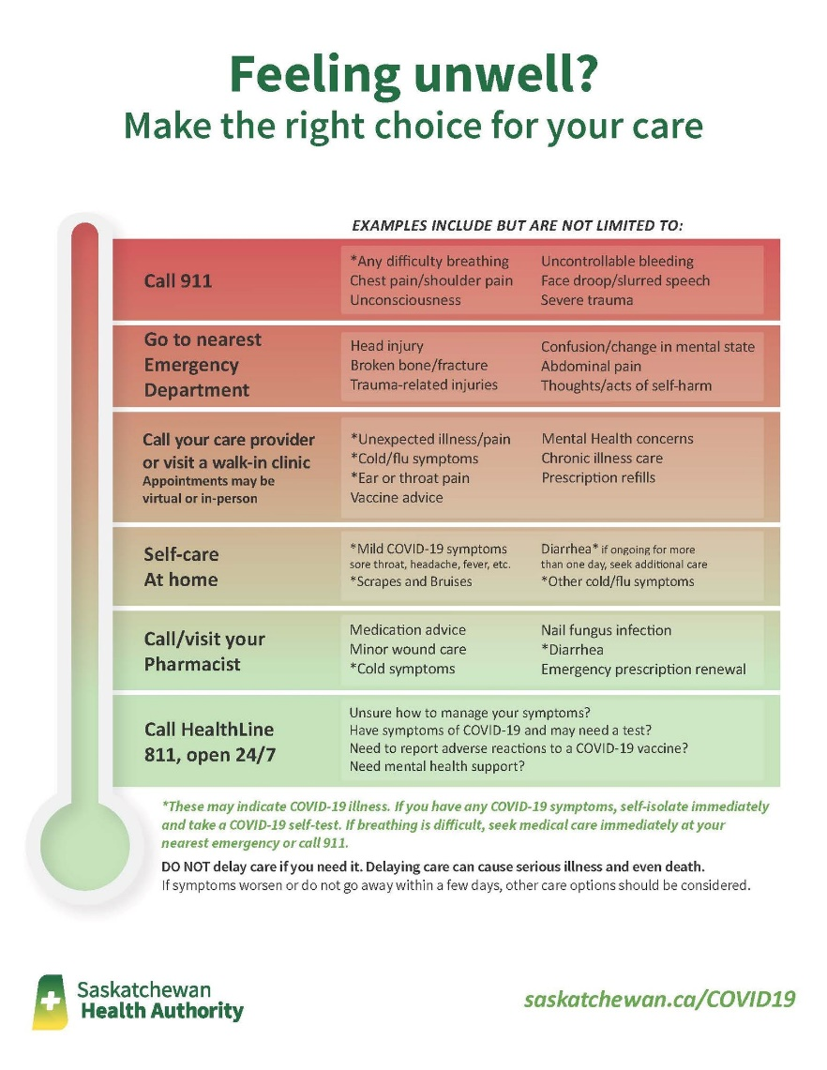

**How emergency rooms work**

Did you know the Emergency Department in the hospital does NOT operate on a first-come, first-served basis; it operates on the triage system. Triaging patients means prioritizing a person based on the urgency of their need for care. After registration, triage is the first thing that happens when you seek care at an emergency room.

The Canadian Triage and Acuity Scale (CTAS) ranges from one to five, with one signifying the sickest patients and five the least sick. The triage nurses do their best to do this as accurately and quickly as possible with the information the patients and family give them. The triage levels are not shared with patients as they can change. There are many factors that move patients up or down the triage scale – age, pain, vital signs, medical history, etc. Learn more: <https://www.saskhealthauthority.ca/.../emergency...>

**Protect yourself / self-care**

As this viral season arrives, we know it can be daunting when your child is ill. We encourage everyone to protect themselves and others from illnesses like COVID-19, RSV and Influenza. Measures you can take include staying home when sick, washing hands, physical distancing, and using masks, especially indoors. If you need advice on when it's time to see your doctor, HealthLine 811 has licensed health-care nurses and professionals standing by who can provide education and support.

**Self-care**

A fever is a rise in body temperature above normal range. It is often a sign that the body is fighting an infection. Fevers don't always need to be treated but rest and hydration are very important. You can also call HealthLine 811 for advice or contact your pharmacist. More: [https://caringforkids.cps.ca/.../hea.../colds_in_children...](https://caringforkids.cps.ca/handouts/health-conditions-and-treatments/colds_in_children?fbclid=IwAR3ejALXRNTpDGvUi48y08gA2m3b0ndk0vD2rvKTLUPulJ9c1Pjj5UHETVU)

**Pediatric care**

A message from Health Canada: "Health Canada is warning families and caregivers not to use adult fever and pain medications on children under 12 years of age unless they consult with a health care professional..."

The ongoing national shortage of pediatric pain/fever medicine is concerning and frustrating but advice is available. If you need advice on whether it’s time to see your doctor, HealthLine 811 has licensed health-care nurses and professionals standing by and can provide education and support.

**Pediatric care**

DO NOT use adult fever and pain medications on children under 12 years of age without consulting a health care professional (pharmacist, nurse practitioner or physician). While we understand the frustration and concern many parents are feeling with the ongoing shortages of pediatric pain and fever medication, adult and child medications are not made or prescribed the same – this may lead to accidental overdose which can be life threatening for children. Every child is unique so don’t use a dosage chart from social media and don’t use expired products.

If your child has a fever, it can mean their body is fighting a virus or infection. For low fevers, try to keep the child comfortable, use cold compresses and have them drink plenty of fluids. Monitor for changes. Warm baths can be useful to help manage pain. You can also call HealthLine 811 for advice when your child is sick. More: <https://caringforkids.cps.ca/.../health.../colds_in_children>

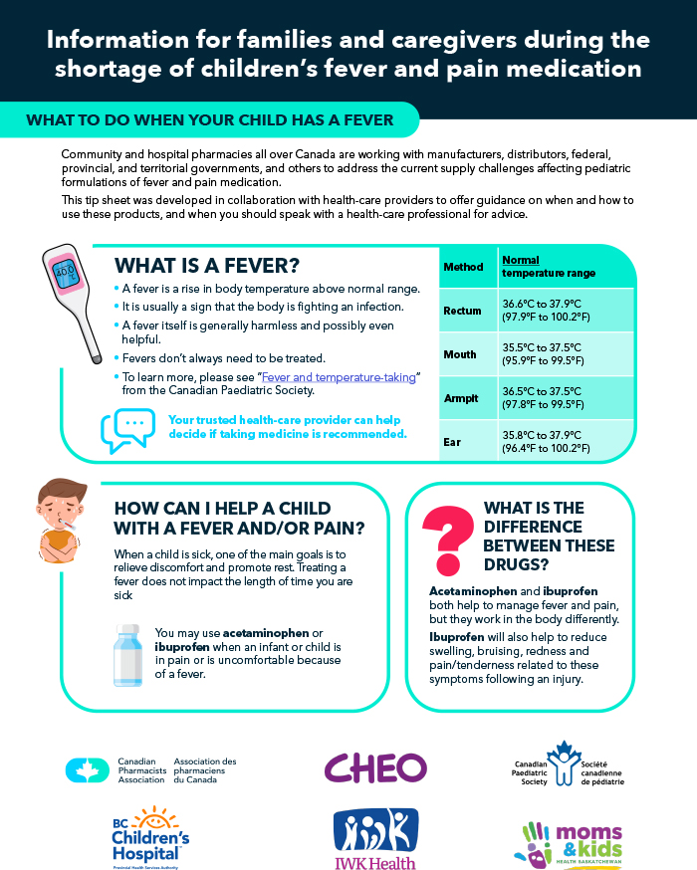

**Respiratory illness information**

Flu season has only just begun in Saskatchewan and the provincial Community Respiratory Illness Surveillance Program (CRISP) of November 10 shows influenza cases already increasing with 61% of those cases being in children and youth. Learn more: [https://www.saskatchewan.ca/.../influenza-cases-in...](https://www.saskatchewan.ca/government/news-and-media/2022/november/15/influenza-cases-in-saskatchewan-get-your-flu-shot-today?fbclid=IwAR3ubPMLBIYV7LMsRloigIbB1ERUK2GBWfzN5B4sYJw-t-YeCpHp3KFjSlw)

Everyone 6 months and older is eligible for the annual flu shot. Book an appointment your flu vaccine today to protect yourself and your family. [www.4flu.ca](https://l.facebook.com/l.php?u=http%3A%2F%2Fwww.4flu.ca%2F%3Ffbclid%3DIwAR1zXZEWEJmdcIdybF8weornGf4jIVtA3ShlSKE42FXiNDzMcWqn9i2dkNs&h=AT3v0g0f8i8UEuyJUDUiNwkp-Jdr5YD4ZYnSRz3d-JLr4tQkjHJq9FuTBR_1jlJwSMZhnEsaCKe6KLje7BcwmxSxrG-6KXCvtnN0x93d757uv1cLBGpBf1Lrwcb4PxWnJw&__tn__=-UK-R&c%5b0%5d=AT0_klE9_ymngSkhc5ayGd2vph6tGcNd-y6_nDiTrgN-J_TuYO4Q8Xd5EwhsXdW_amvYYnF1K6VylNLN-Os6q9OdDthEdg8GxIsr9HmFk9tuPLPS5-18YU9zmhm5GNaiX8nqddAdQlKVEOCShQJ9HYkKXzGpIIdpgBorqQSM89asdzG9PlQAC7QBTTVKLGSx0zC6L7DXVUBy)



**Health Screening Questionnaire**

All people entering schools are encouraged to conduct a health screening before entering any

GSCS school or building to help prevent the spread of illnesses.

Fever

Dizziness

Headache

Conjunctivitis/

Pink eye

Muscle/joint aches

Loss of sense

of taste or smell

Unexplained loss

of appetite

Nausea/vomiting/

diarrhea

Feeling unwell/

Fatigued

St. Frances…. Reaching Out . . . *to Transform the World!!*

VIRTUE AND TIPI TEACHING OF THE MONTH

RESPECT